**Mandla Ndebele**

**Student Number; ST10463908**

**Mobile App Scripting MAST5112**

**1.1 Pictures of screen design**

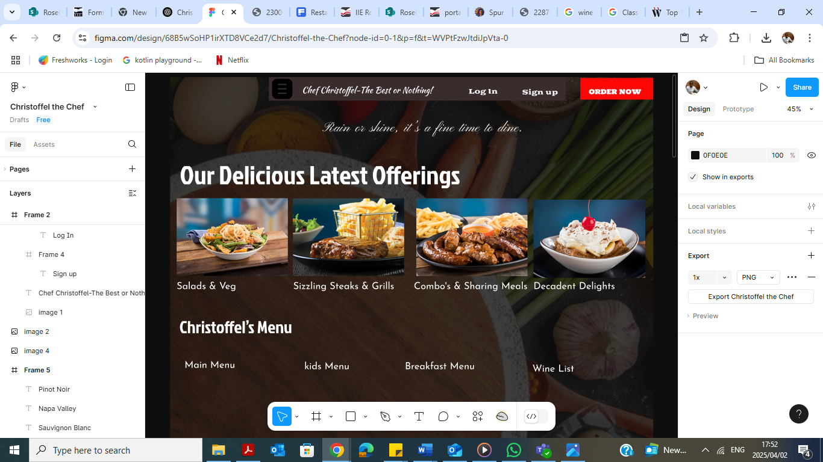

**1.2 pictures of wireframes**

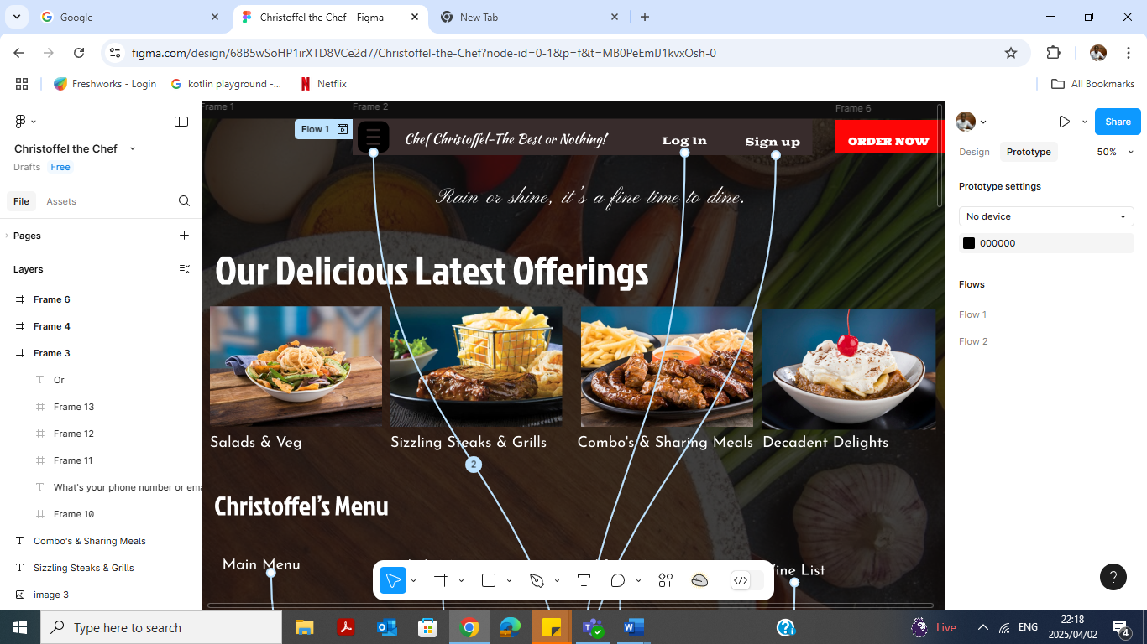

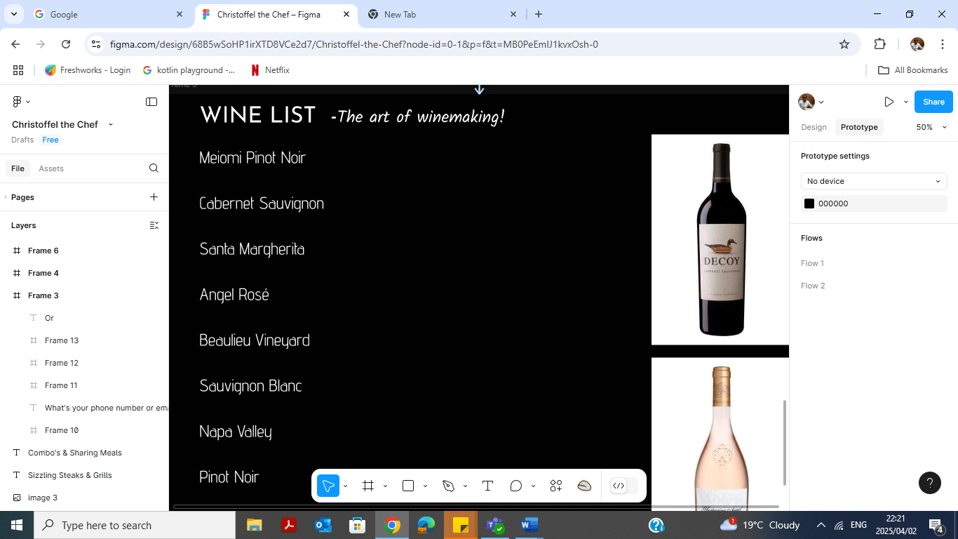

**Reference list**

* Spur Steak Ranches https://www.spursteakranches.com/za/menu